**SQL FUNDAMENTALS**

**AND, OR & NOT Operators**

**Introduction**

In SQL, **AND, OR & NOT** keywords are called operators. In particular, they are called logical operators. Their purposes are filtering the data based on conditions.

The WHERE clause can be combined with AND, OR & NOT operators. Let's start with the AND operator.

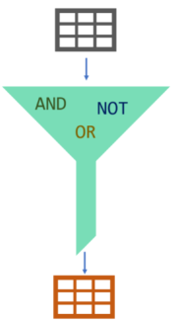

**AND Operator**

The AND operator is used with the WHERE clause and combines multiple expressions. It returns only those records where both conditions (in WHERE clause) evaluate to True. The syntax has the following form in the WHERE condition:

WHERE left_conditon AND right_condition

Now, display the employees whose title is a data scientist and gender is male. You would be asked for the same thing as "show me the male data scientists in the company. " They are both the same.

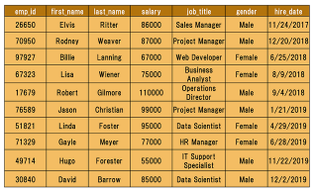

There are two conditions here. One is the title of the employee is a data scientist, other is the gender of his/her should be male. The correct search condition in where clause is job_title = 'data scientist' AND gender = 'Male'.

Let's write the query.

query :

FROM employees

WHERE job_title = 'Data Scientist' AND gender = 'Male';

There is only one record that meets both conditions. So only one record returns.   
  
output :

emp_id first_name last_name salary job_title gender

    hire_date

---------- ---------- ---------- ---------- -------------- ----------

    ----------

30840 David Barrow 85000 Data Scientist Male 2019-12

    -02

### OR Operator

The OR operator is used with the WHERE clause and combines multiple expressions. It displays the record where either one of conditions (in WHERE clause) evaluates to True. The syntax has the following form in the WHERE condition.

WHERE first_condition OR second_condition

Display the employees whose title is a data scientist or gender is male.   
  
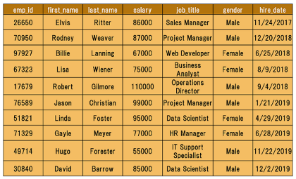

query :

SELECT *

FROM employees

WHERE job_title = 'Data Scientist' OR gender = 'Male';

The query returns all the male employees and data scientists. Since there is a female data scientist, the result table also displays it.  
  
output :

emp_id first_name last_name salary job_title

     gender hire_date

---------- ---------- ---------- ----------

    ------------------- ---------- ----------

17679 Robert Gilmore 110000 Operations

    Director Male 2018-09-04

26650 Elvis Ritter 86000 Sales Manager

     Male 2017-11-24

30840 David Barrow 85000 Data Scientist

     Male 2019-12-02

49714 Hugo Forester 55000 IT Support

    Speciali Male 2019-11-22

51821 Linda Foster 95000 Data Scientist

     Female 2019-04-29

70950 Rodney Weaver 87000 Project Manager

     Male 2018-12-20

76589 Jason Christian 99000 Project Manager

     Male 2019-01-21

As we mentioned above, the records which meet either of the conditions return as a result. 

**💡 Tip:** Don't get confused with ANDs and ORs!

* When you want **ALL** of your conditions to be true, use **AND**
* When you want **ANY** of your conditions to be true, use **OR**

### NOT Operator

The NOT operator is used to negate a condition in the WHERE clause. NOT is placed right after WHERE keyword. You can use it with AND & OR operators. Here is the syntax of NOT operator.

WHERE NOT first_condition

Display the male employees.   
  
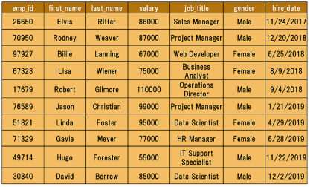

At first, you may write this query:

SELECT *

FROM employees

WHERE gender = 'Male';

We can also write it in another way using NOT operator.  
  
query :

SELECT *

FROM employees

WHERE NOT gender = 'Female';

Both queries will yield the same result below.  
  
output :

